LEX Program to Identify and Print Assignment Operators

AIM:
To write a LEX program to identify and print all assignment operators (=, +=, -=, *=, /=) used in a given C program

PSEUDOCODE:
- Start the program.
- Define patterns for the assignment operators.
- Read the input C program.
- Identify the matching assignment operator.
- Print the identified operator.
- Ignore spaces and other characters.
- Stop the program.

Program:

%{
#include <stdio.h>
%}

%%
"+=" { printf("Assignment operator: +=\n"); }
"-=" { printf("Assignment operator: -=\n"); }
"*=" { printf("Assignment operator: *=\n"); }
"/=" { printf("Assignment operator: /=\n"); }
"=" { printf("Assignment operator: =\n"); }
[ \t\n]+ ;
. ;
%%

int main()
{
yylex();
return 0;
}

int yywrap()
{
return 1;
}

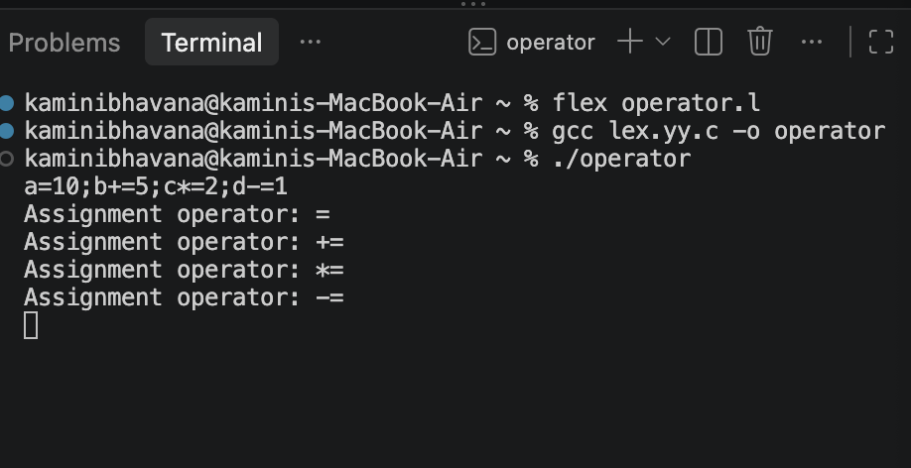
OUTPUT:

Result:
Thus, the LEX program was successfully implemented to identify and print the assignment operators present in the given C program.

